Ideation Phase

Define the Problem Statements

|  |  |
| --- | --- |
| Date | 24 MAY 2023 |
| Team ID | NM2023TMID11394 |
| Project Name | Gas Pipeline Monitoring System For Hospitals |

Customer Problem Statement:

User from the department of Gas Pipeline Monitoring System For Hospital.The imaging tool, such as Chest X-ray (CXR), can speed up the identification process. Therefore, our objective is to develop an automated CAD system for the detection of COVID-19 samples from healthy and pneumonia cases using CXR images.

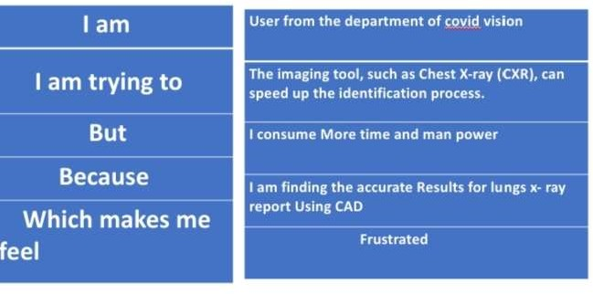

|  |  |  |  |  |  |
| --- | --- | --- | --- | --- | --- |
| **Problem**  **Statement (PS)** | **Iam**  **(Customer)** | **I’m trying to** | **But** | **Because** | **Which makes me feel** |

|  |  |  |  |  |  |
| --- | --- | --- | --- | --- | --- |
| Gas Pipeline Monitoring System For Hospitalsdetection | User from the department Gas Pipeline Monitoring System For Hospitals | The imaging tool, such as , can speed up the identificatio  n process. | It consumes lot of time and man | We are finding theGas Pipeline Monitoring System For Hospitals | Frustrated and exhausted. |